Batch: A3 Roll No.: 2021004

Experiment / assignment / _Mini Project__

Grade: AA / AB / BB / BC / CC / CD /DD

Signature of the Staff In-charge with date

TITLE: Python Application Development

AIM: To develop a python application for a real-world problem
______________________________________________________________________
Expected OUTCOME of Experiment:

CO1: Describe the Numbers, Math functions, Strings, List, Tuples and Dictionaries in Python
CO2: Interpret different Decision-Making statements, Functions, Object oriented
programming in Python
CO3: Understand and summarize different File handling operations
CO4: Explain how to design GUI Applications in Python and evaluate different
database operations

_____________________________________________________________________
Books/ Journals/ Websites referred:

1. https://www.geeksforgeeks.org/
2. https://docs.python.org/3/library/os.html
3. https://docs.python.org/3/library/sys.html
4. https://pypi.org/project/pyttsx3/2.7/

_____________________________________________________________________

GitHub Link of Project files:
https://github.com/LuvArora-coder/Inventory-Management-System.git

Problem statement:
To build an application for managing inventory system which lets people purchase raw materials according to their needs. This inventory management system focuses on purchasing of raw materials for constructions. Admins have the management authority to keep checks in place.

Scope:
  - Our project will have user login and admin login.
    - User Login: When a user logs in, they will be only able to see the listing of the products and will be able to add them to the cart and also buy them.
    - Admin Login: An admin can add or remove a product from the system.

  - Our project will have following modules / functionalities:
    - Purchase an item: A user can purchase any product by adding to cart.
    - Add an item: An admin can add a product into the product listing
    - Delete a product: An admin can delete a product from the product listing
    - Search a product: We can also search a product by its name.
    - Bill: A bill is produced after a purchase is done successfully.

Component diagram:
Admin Module Flowchart:
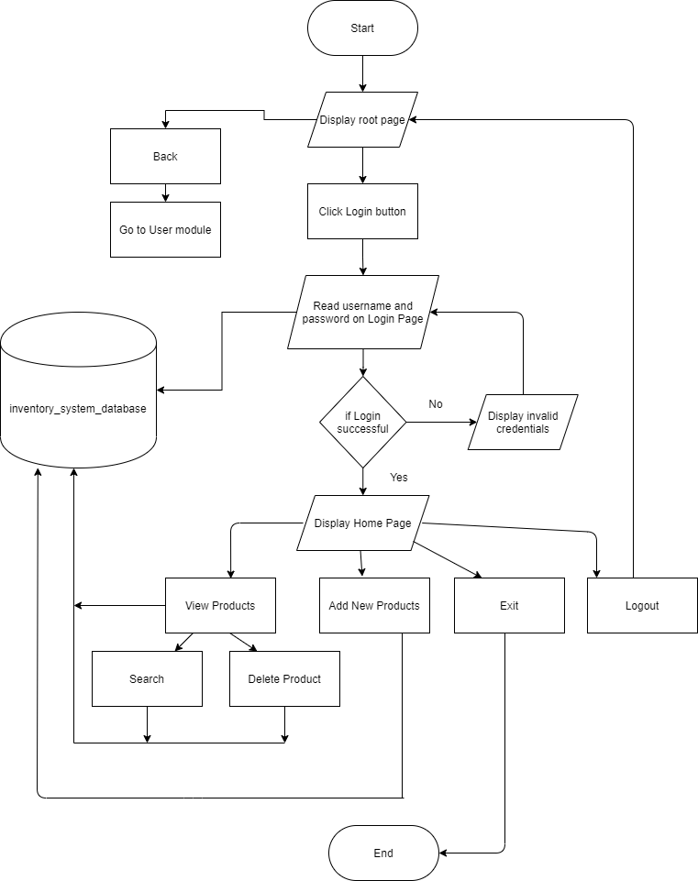

User Module Flowchart:
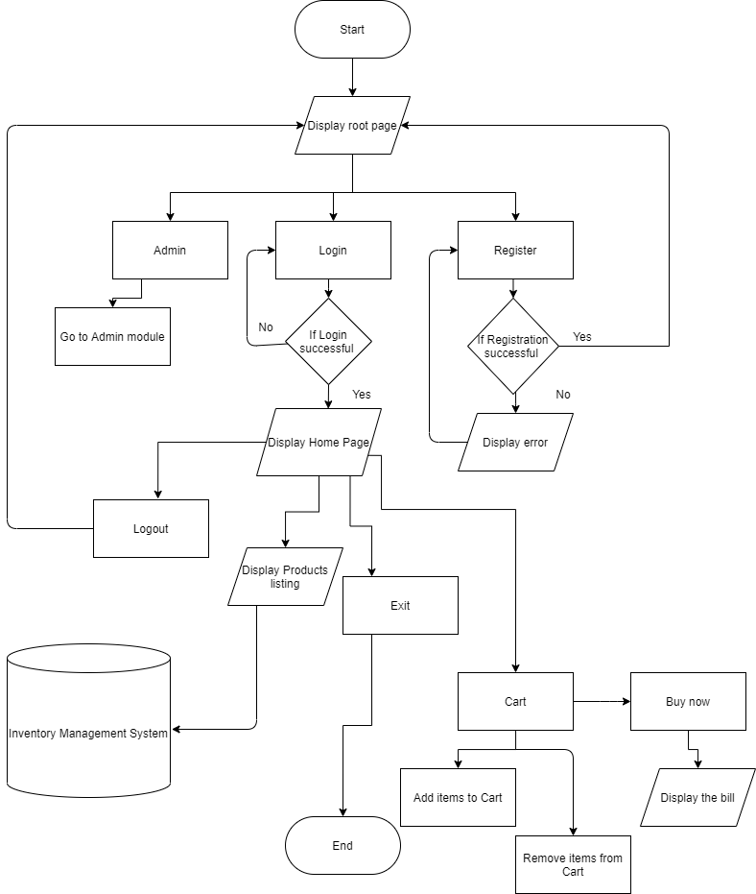
API or package used:
- Tkinter
  - Tkinter is a GUI framework that is built into Python standard library
  - We used Tkinter to create the UI of our application
- MySQLdb
  - MySQLdb is an interface for connecting to a MySQL database server from Python.
  - We used MySQL to work with databases.
  - We performed CRUD (create, read, update, delete) operations on the database
- PIL (pillow)
  - Pillow is built on top of PIL (Python Image Library). PIL is one of the important modules for image processing in Python.
  - We used PIL module to work with images such as displaying background image.
- os
  - The OS module in Python provides functions for interacting with the operating system.
  - os.system() method was used for opening and running different python files.
- time
  - Used for printing system’s current date and current time on the bill.
- sys
  - Provides access to some variables used or maintained by the interpreter and to functions that interact strongly with the interpreter.

Difficulties faced and measures taken to resolve:
- Tkinter (setting background image):
  - Setting up background image was difficult using frames or directly on the root object. The image would not set in the exact position with exact width and length
  - Solution: We used canvas for placing background image. Canvas is especially used for complex layouts. On top the canvas we placed our widgets like buttons or labels.
- Logging in again after logging out in admin module:
  - The login window redirects to Home window after successful login completion. After logging out, it redirects back to root window from where we can login again. However, after logging in again, instead of redirecting to Home window, the program would give an error.
  - Solution: We created another python file for the Home window and called that file using os.system() method to open it.
- Add to Cart in user module:
  - Implementing Add to Cart by using tables proved to be challenging for us.
  - Solution: We opted for a simpler way to implement it by using dictionaries. It was now easier to print, remove items from the cart, and print that on the bill.
Team work (Contribution of each member):
Task | Luv Arora | Sarwasvi Ingoley
UI:
Design | ✓ | ✓
Coding | ✓ | ✓
Database:
Table design | ✓ | ✓
Query design | ✓ | ✓
Coding | ✓ | ✓
Program:
Admin Module |  | ✓
User Module | ✓
Add to Cart / Buy Now Module | ✓ | ✓
Testing:
Test Cases | ✓ | ✓
Presentation:
Report |  | ✓
PowerPoint | ✓

Conclusion:
Hence, we understood all the concepts taught to us during this course. We implemented most of the concepts and got a deeper understanding of the subject.

